**ASSIGNMENT – 4**

1. **Pulled an image from docker hub and ran it in console (Local Machine)**

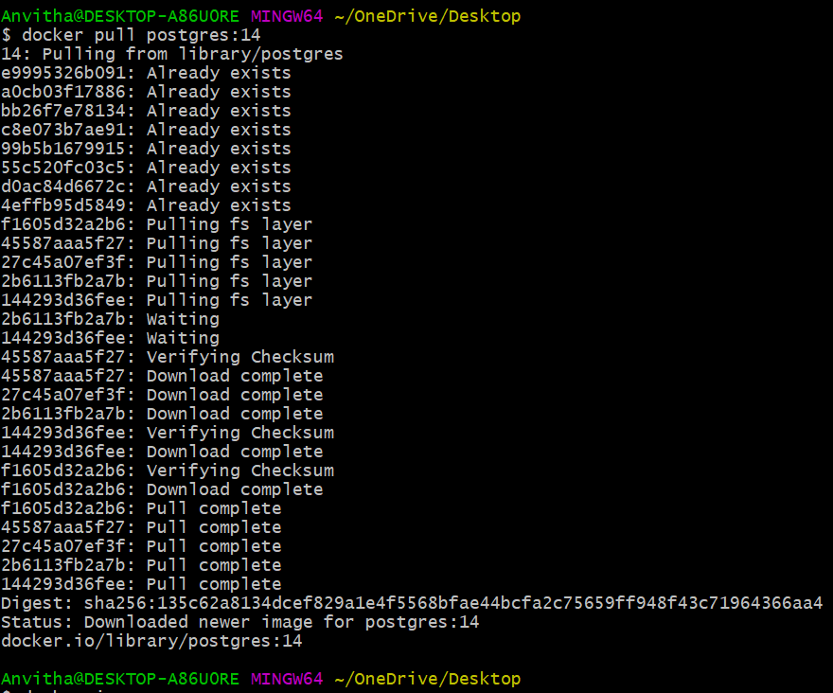

**Pull an image from docker hub and ran it in docker playground**

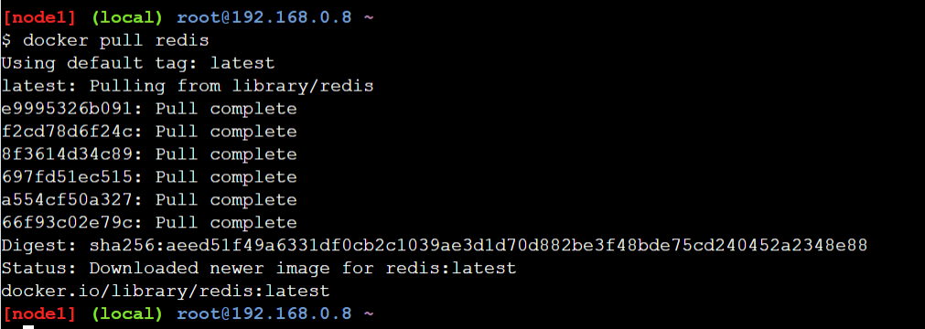

1. **Create a docker file and deploy it in docker desktop application**

